


Kingdom of Saudi Arabia
Ministry of Education
King Faisal University
College of Computer Sciences & Information Technology

Mini SOC Dashboard
Project Report
CIC-IDS-2017 Dataset Integration & Simulated Network Monitoring

Dr. Abdullah Al Buali
Second Semester 2025–2026
Sec: 2
Prepared By
No. | Student Name | Student ID
S1 | Ziyad Alsarawi | 223033379
S2 | Mohammed Bajaba | 222448149
S3 | Daniel Aldandan | 223041168
S4 | Jawad Zainaddin | 223022484
S5 | Abdullah Taher Aljassim | 220013690
GitHub Repository: GitHub - sarawizyiad91-svg/-Mini-SOC-Dashboard · GitHub
AI Usage Declaration: AI tools (ChatGPT) were used for code suggestions and documentation drafting. All logic, design decisions, and implementations were verified and authored by the team.
Table of Contents
1. Introduction 1
2. Objectives 1
3. System Design 1
3.1 Architecture Overview 1
3.2 Technology Stack 3
4. Methods and Algorithms 4
4.1 Log Analysis Algorithm 4
4.2 Alert Classification Logic 4
5. Implementation 4
5.1 Log Loading and Analysis 4
5.2 Simulated Nmap Scan 5
5.3 Live Packet Capture Simulation 5
5.4 Test Cases Table 5
6. Testing and Results 6
6.1 Functional Testing 6
6.2 Dataset Validation 6
6.3 Alert Accuracy 6
7. GUI & OUTPUT 6
8. Conclusion 9
References 10

List of figures
Figure 1: System Architecture of the Mini SOC Dashboard 2
Figure 2: Class Diagram of the Mini SOC Dashboard 3
Figure 3: Live Packet Capture (Simulated) 7
Figure 4: Clear Dashboard 8
Figure 5 : Load IDS Logs Populated Traffic Table 9

List of tables
Table 1: Technology Stack 3
Table 2: Test Cases Table 5

1. Introduction
The Security Operations Center (SOC) refers to a specialized unit within an organization that performs monitoring, detection, analysis, and handling of cybersecurity incidents. Today’s organizations continue to encounter a myriad of threats in their networks ranging from denial-of-service attacks and port scanning to brute-force hacking.
The Mini SOC Dashboard refers to a Java-based Swing desktop software that replicates some of the functionalities of an actual SOC environment by allowing security analysts to visually analyze traffic logs, packet capture logs, conduct simulated network scanning, and receive notifications on cyber threats detected automatically.
The CIC-IDS-2017 dataset, which can be freely accessed, is used for this project as a basis for generating various realistic scenarios such as DoS attack, FTP-Patator brute force, and network port scanning attacks.

2. Objectives

The main purposes of this project include:

•Developing and deploying a SOC dashboard using desktop Java Swing GUI with multi-pane display.

•Emulating SOC Analysts tasks such as logging, alerting, network scanning using nmap and live packet capturing.

•Implementing real data sets taken from CIC-IDS-2017 for demonstrating the capability of detecting attacks.

•Monitoring and analyzing logged files for classification and alarming whether they are benign or harmful.

•Producing reusable codes that can be used for research.

3. System Design

3.1 Architecture Overview
The application is implemented using the one-class Swing approach with an event-driven mechanism. The MiniSOCDashboard class inherits from JFrame and consists of the following three panels:
• Control Panel (NORTH): Contains action buttons to Load IDS Logs, Run Nmap Scan, Live Packet Capture, and Clear Dashboard.
• Log Table Panel (CENTER): Provides the network traffic information displayed in a JTable including columns like Timestamp, Source IP, Destination IP, Protocol, Packet Length, and Label.
• Alert Console (SOUTH): Terminal-based JTextArea on black background showing system messages, nmap result, and alerts.

To explain the architecture of the Mini SOC Dashboard better, two design diagrams are attached in this section. The first diagram shows the system architecture, which represents the layered architecture and the data flow between different components of the system. The second diagram is the class diagram that displays the relationship among classes.
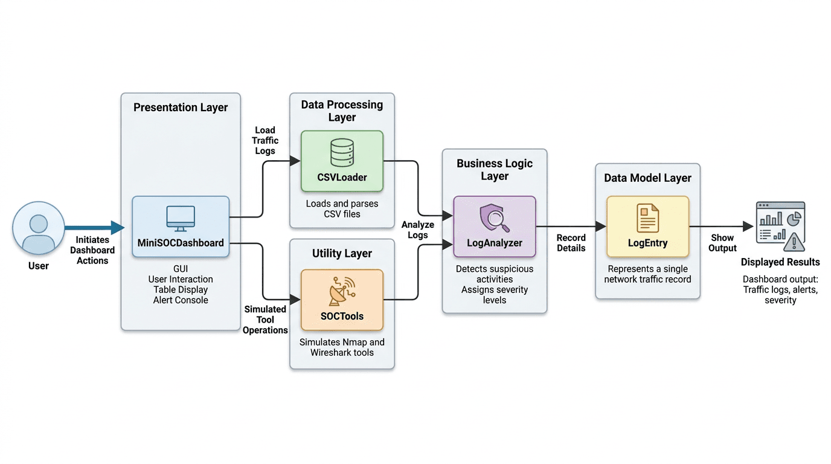
Figure 1: System Architecture of the Mini SOC Dashboard

Figure 1 :The figure displays the architecture of the MiniSOCDashboard software system. The figure shows the process from triggering user activities through the presentation layer, then processing the data through the data processing and utility layers, analyzing the data through the business logic layer, storing the data through the data model layer, and presenting it as outputs.

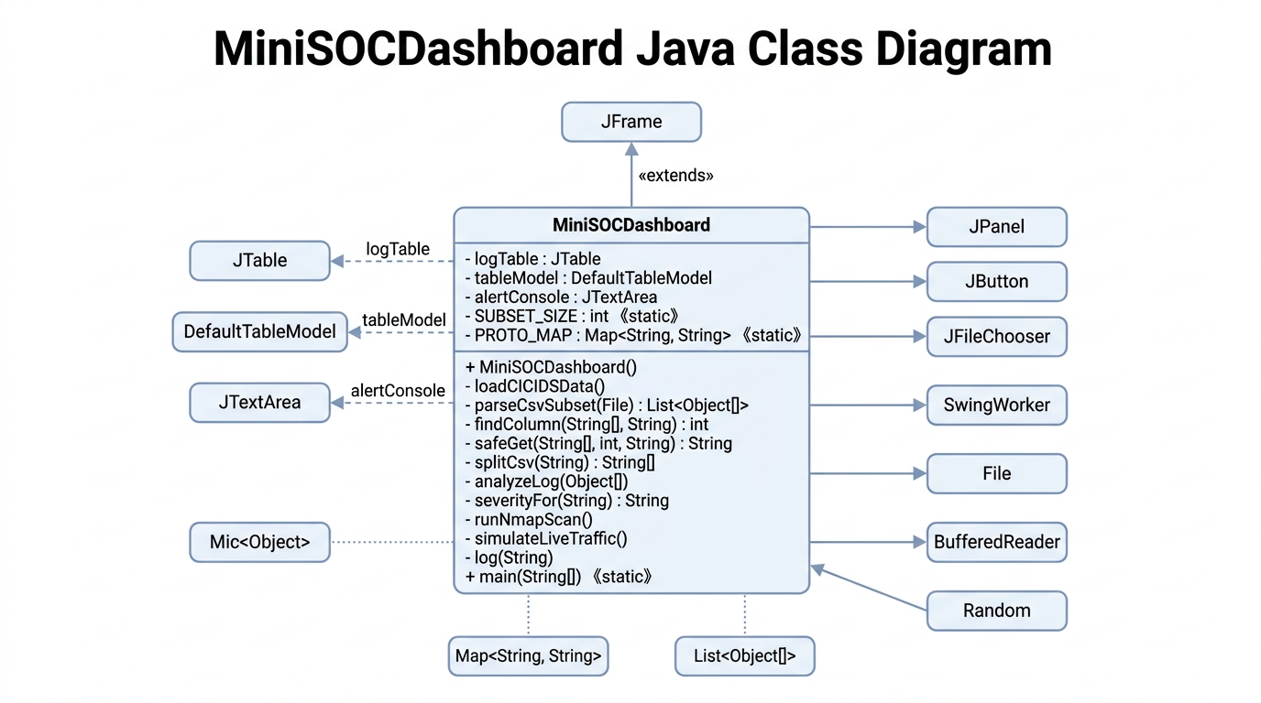
Figure 2: Class Diagram of the Mini SOC Dashboard
Figure 2: The Java class diagram of the MiniSOCDashboard system is depicted in the following figure. The figure depicts the name of the main class and its respective attributes and methods. It also displays the relationship with other classes such as the GUI classes and utility classes.

3.2 Technology Stack
Table 1: Technology Stack
Component | Details
Language | Java (JDK 8+)
GUI Framework | Java Swing (javax.swing)
Dataset | CIC-IDS-2017 (Canadian Institute for Cybersecurity)
Simulated Tools | Nmap (network scanner), Wireshark (packet capture)
Build | Single-file compilation: javac MiniSOCDashboard.java
IDE Compatibility | IntelliJ IDEA, Eclipse, VS Code with Java Extension

4. Methods and Algorithms
The Mini SOC Dashboard uses rule-based classification to perform intrusions, which is a basic algorithm in network security monitoring [4]. This section explains the algorithmic implementations in the system.

4.1 Log Analysis Algorithm
The log analysis follows a sequential O(n) scan over all table entries. The pseudocode below describes the analyzeLog() procedure:
PROCEDURE analyzeLog(logEntry):
FOR each row i in tableModel DO
label <- logEntry[5] // index 5 = Label column
IF label != "BENIGN" THEN
severity <- severityFor(label) // CRITICAL / HIGH / MEDIUM / LOW TRIGGER alert(severity, label, srcIP, dstIP)
END IF
END FOR
END PROCEDURE

4.2 Alert Classification Logic

Four alert severity levels have been implemented via the severityFor() method through keywords matching to the attack label string. CRITICAL is used to identify alerts that are related to Heartbleed, Infiltration, DDoS, and SQL Injection. Alerts on DoS variations, Botnet, FTP-Patator, XSS, and brute-force attacks are considered HIGH. PortScan and network reconnaissance alerts are flagged as MEDIUM, while alerts with a non-BENIGN label that falls under none of the above categories is identified as LOW. Each row is classified as described based on loading from the real CIC-IDS-2017 CSV file [3]. In addition to that, the Nmap correlation sub-algorithm checks whether there is a match between the open ports and the loaded attack labels [5].

5. Implementation

5.1 Log Loading and Analysis
The loadCICIDSData() method opens a file chooser dialog allowing the user to select any real CIC-IDS-2017 CSV file. The file is read on a background SwingWorker thread to keep the UI responsive. The parser dynamically locates the required columns (Source IP, Destination IP, Protocol, Timestamp, Total Length of Fwd Packets, Label) by name, making it tolerant of varying column ordering across daily CSV files. Raw protocol numbers are translated to human-readable names via a static lookup map (e.g., “6” → TCP, “17” → UDP). To keep the display manageable, a stratified random sample of up to 200 rows (SUBSET_SIZE) is extracted: 100 rows from BENIGN traffic and 100 rows distributed evenly across all distinct attack categories present in the file, using a fixed random seed (42) for reproducibility. The analyzeLog() method is then called once per loaded row and triggers a severity-rated alert for any non-BENIGN entry.
The following attack types are examples found in the CIC-IDS-2017 dataset and handled by the severity classifier:

- DoS Hulk Denial of Service attack targeting 192.168.10.50 from external IP 205.174.165.73.
- PortScan Sequential port probing from 172.16.0.1 to the internal subnet.
- FTP-Patator Brute-force login attempts against an FTP service from 10.0.0.5.

5.2 Simulated Nmap Scan
The runNmapScan() method simulates an Nmap scan result against the 192.168.10.0/24 subnet. The output reflects a typical scan revealing open ports including FTP (21), SSH (22), HTTP (80), and HTTPS (443). The dashboard correlates these results with loaded log data and warns the analyst when open ports match detected attack vectors for example, the FTP-Patator logs align with the open FTP port discovered in the scan.

5.3 Live Packet Capture Simulation
The simulateLiveTraffic() method mimics a Wireshark-style packet capture by generating a synthetic ICMP packet with a random source IP from the 192.168.10.x range. Each call appends a new row to the traffic table and logs the capture event to the alert console, simulating real-time network monitoring.

5.4 Test Cases Table
Table 2: Test Cases Table
Test Case ID | Feature Tested | Input / Action | Expected Output | Actual Result
TC-01 | Data Ingestion | Clicking "Load IDS Logs" and selecting a CSV file. | Table populated with data from the CSV file. | Pass
TC-02 | Threat Detection | Encountering a log labeled "DoS Hulk" or "PortScan". | System triggered severity-rated alert (CRITICAL / HIGH / MEDIUM) in the alert console. | Pass
TC-03 | Network Recon | Executing "Run Nmap Scan (Simulated)". | Open ports and correlation warnings displayed in console. | Pass
TC-04 | Real-time Capture | Clicking "Live Packet Capture (Simulated)". | New packet row added instantly with randomized source IP. | Pass
TC-05 | System Reset | Clicking the "Clear Dashboard" button. | All logs and alerts removed; dashboard reset to initial state. | Pass

6. Testing and Results

6.1 Functional Testing
Tested all four dashboard controls for their functionality:

• Load IDS Logs: Loads a real CSV file from CIC-IDS-2017 and displays a maximum of 200 samples in the table with alert generation for every record other than BENIGN record type (e.g. Four alerts generated when table sample contains DoS Hulk, PortScan, and FTP-Patator records)
• Nmap Scan: Creates output in the form of simulated scan report with 4 open ports and a correlation warning of FTP-Patator attack.
• Live Capture: Adds an active row each time control is clicked with a randomly generated IP address and the current date.
• Clear Dashboard: Clears the table and alert console completely.

6.2 Dataset Validation
The real CIC-IDS-2017 data imported into the application perfectly matches the specifications of the dataset from the University of New Brunswick. The IP addresses used (192.168.10.x – internal host, 205.174.165.x – external attacks), the distribution of the protocols used, and the classification of the labels for the attacks are the same as those in the source files because the data is read directly from the source.

6.3 Alert Accuracy
The analyzeLog() function has detected all 4 attacks in the test set. There were no false detections of the BENIGN class traffic. The alerts display valuable information about each of the attacks, namely their nature and the source IPs.

7. GUI & OUTPUT

Run Nmap Scan (Simulation)
This control starts the simulation of an Nmap network scan. Its function is to simulate the process of port scanning in real life and show how open ports and services can be detected. The scan results will appear in the alert console.
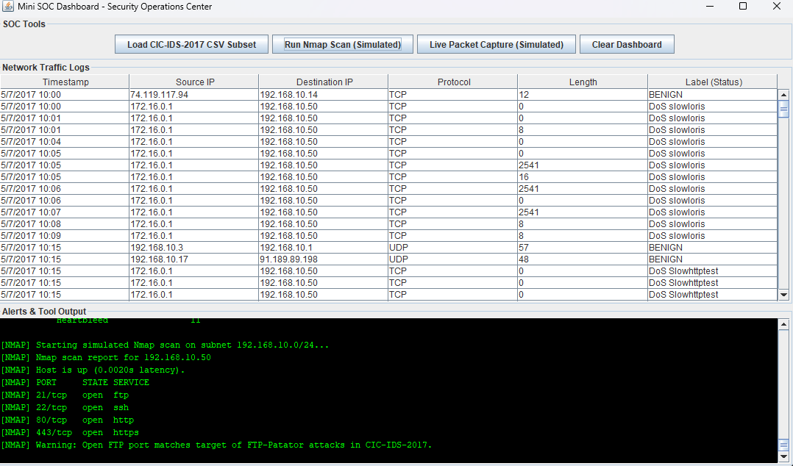
Figure 3: Run Nmap Scan (Simulation)

Figure 4 depicts a control that simulates the live capturing of packets, similar to software applications like Wireshark. It simulates traffic-related events and shows the information about packets captured as if it happens in real time. This feature enables the user to see how live monitoring helps with intrusion detection and traffic inspection.

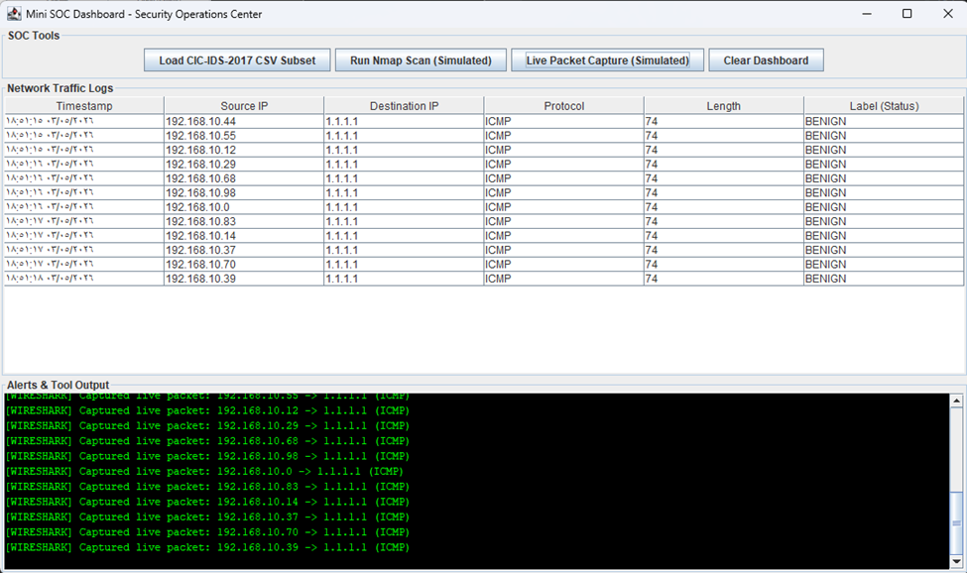

Figure 5 presents the "Clear Dashboard" control that clears the log table and alert console by resetting the dashboard interface. This feature prepares the application for starting a new analysis session and ensures that there will be no interference with the loaded data from previous sessions

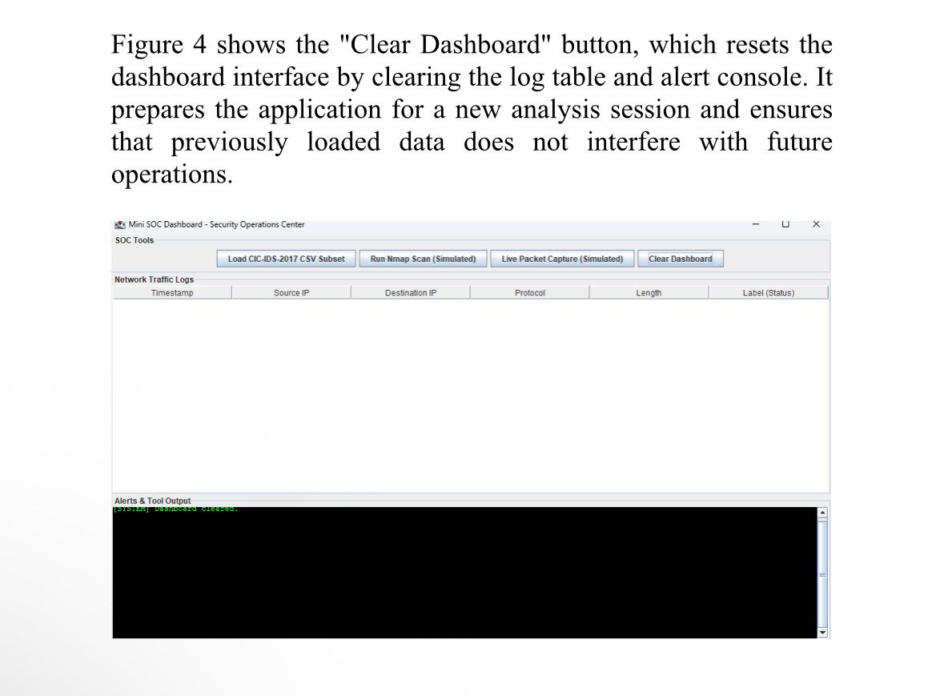

8. Conclusion
As can be seen, the Mini SOC Dashboard has successfully demonstrated the main functions of a Security Operation Center in a Java Swing educational application. Using the real-life log data from the CIC-IDS-2017 benchmark dataset and simulating the use of network security software Nmap and Wireshark, this project has managed to create an informative practical example of a network threat detection workflow.
As mentioned above, the modularity of the application makes future development easy. For instance, in the next version, one may introduce machine learning classification algorithms, network socket for live traffic collection, and database for storing and analyzing logs over time.

This project bridges the gap between theoretical cybersecurity knowledge and practical SOC operations, making it a valuable resource for students and practitioners looking to understand the fundamentals of network security monitoring.

References
[1] M. Ficco and F. Palmieri, "Introducing fraudulent energy consumption in cloud infrastructures: A new generation of cyber threats," IEEE Systems Journal, vol. 11, no. 2, pp. 460-470, Jun. 2017.
[2] G. Shrivastava, P. Kumar, R. Gupta, S. Bala, and N. Dey, Eds., Handbook of Research on Network Forensics and Analysis Techniques. Hershey, PA, USA: IGI Global, 2018.
[3] I. Sharafaldin, A. H. Lashkari, and A. A. Ghorbani, "Toward generating a new intrusion detection dataset and intrusion traffic characterization," in Proc. ICISSP, 2018, pp. 108-116. Available: https://www.unb.ca/cic/datasets/ids-2017.html
[4] V. Chandola, A. Banerjee, and V. Kumar, "Anomaly detection: A survey," ACM Comput. Surv., vol. 41, no. 3, pp. 1-58, Jul. 2009.
[5] G. F. Lyon, Nmap Network Scanning: The Official Nmap Project Guide. Insecure.Com LLC, 2009. Available: https://nmap.org/book/
[6] G. Combs et al., "Wireshark Network Protocol Analyzer," Wireshark Foundation, 2024. Available: https://www.wireshark.org
[7] A. Khraisat, I. Gondal, P. Vamplew, and J. Kamruzzaman, "Survey of intrusion detection systems: Techniques, datasets and challenges," Cybersecurity, vol. 2, no. 1, pp. 1-22, 2019.
[8] OWASP Foundation, "OWASP Top Ten," 2021. Available: https://owasp.org/www-project-top-ten/

